**EXPERIMENT - 1.1**

**AIM :-** Installation of Python.

**THEORY :-**

**What is python?**

Python is an interpreted high-level programming language for general-purpose programming. Created by Guido van Rossum and first released in 1991, Python has a design philosophy that emphasizes code readability, and a syntax that allows programmers to express concepts in fewer lines of code, notably using significant whitespace. It provides constructs that enable clear programming on both small and large scales.

Python features a dynamic type system and automatic memory management. It supports multiple programming paradigms, including object-oriented, imperative, functional and procedural, and has a large and comprehensive standard library.

Python interpreters are available for many operating systems. Python, the reference implementation of Python, is open source software and has a community-based development model, as do nearly all of its variant implementations. CPython is managed by the non-profit Python Software Foundation.

### **Features of python**:-

* Easy-to-learn − Python has few keywords, simple structure, and a clearly defined syntax. This allows the student to pick up the language quickly.
* Easy-to-read − Python code is more clearly defined and visible to the eyes.
* Easy-to-maintain − Python's source code is fairly easy-to-maintain.
* A broad standard library − Python's bulk of the library is very portable and cross-platform
* compatible on UNIX, Windows, and Macintosh.
* Interactive Mode − Python has support for an interacƟve mode which allows interactive testing and debugging of snippets of code.
* Portable − Python can run on a wide variety of hardware plaƞorms and has the same interface on all platforms.
* Extendable − You can add low-level modules to the Python interpreter. These modules enable programmers to add to or customize their tools to be more efficient.
* Databases − Python provides interfaces to all major commercial databases.
* GUI Programming − Python supports GUI applicaƟons that can be created and ported to many system calls, libraries and windows systems, such as Windows MFC, Macintosh, and the X Window system of Unix.
* Scalable − Python provides a beƩer structure and support for large programs than shell scripting.

**Downloading** :-

1. Click on Download Python.

The following page will appear in your browser.

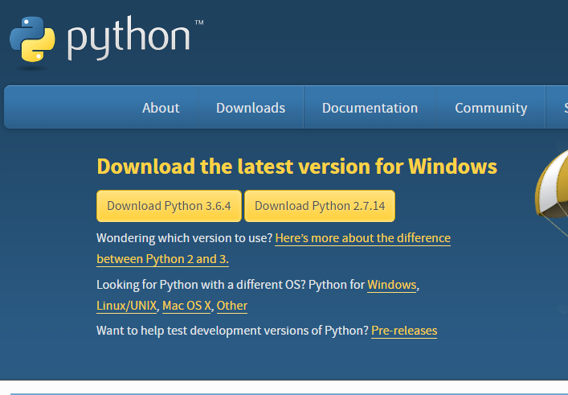

1. Click the **Download Python 3.6.4** button.
2. The Python download requires about 30 Mb of disk space; keep it on your machine, in case you need to re-install Python. When installed, Python requires about an additional 90 Mb of disk space.

The file should appear as:



1. Start the **Installing** instructions directly below.

**Installing** :-

1. Double-click the icon labelling the file **python-3.6.4.exe**. and click on install now.
2. Click **Run**.

A **Python 3.6.4 (32-bit) Setup** pop-up window will appear.

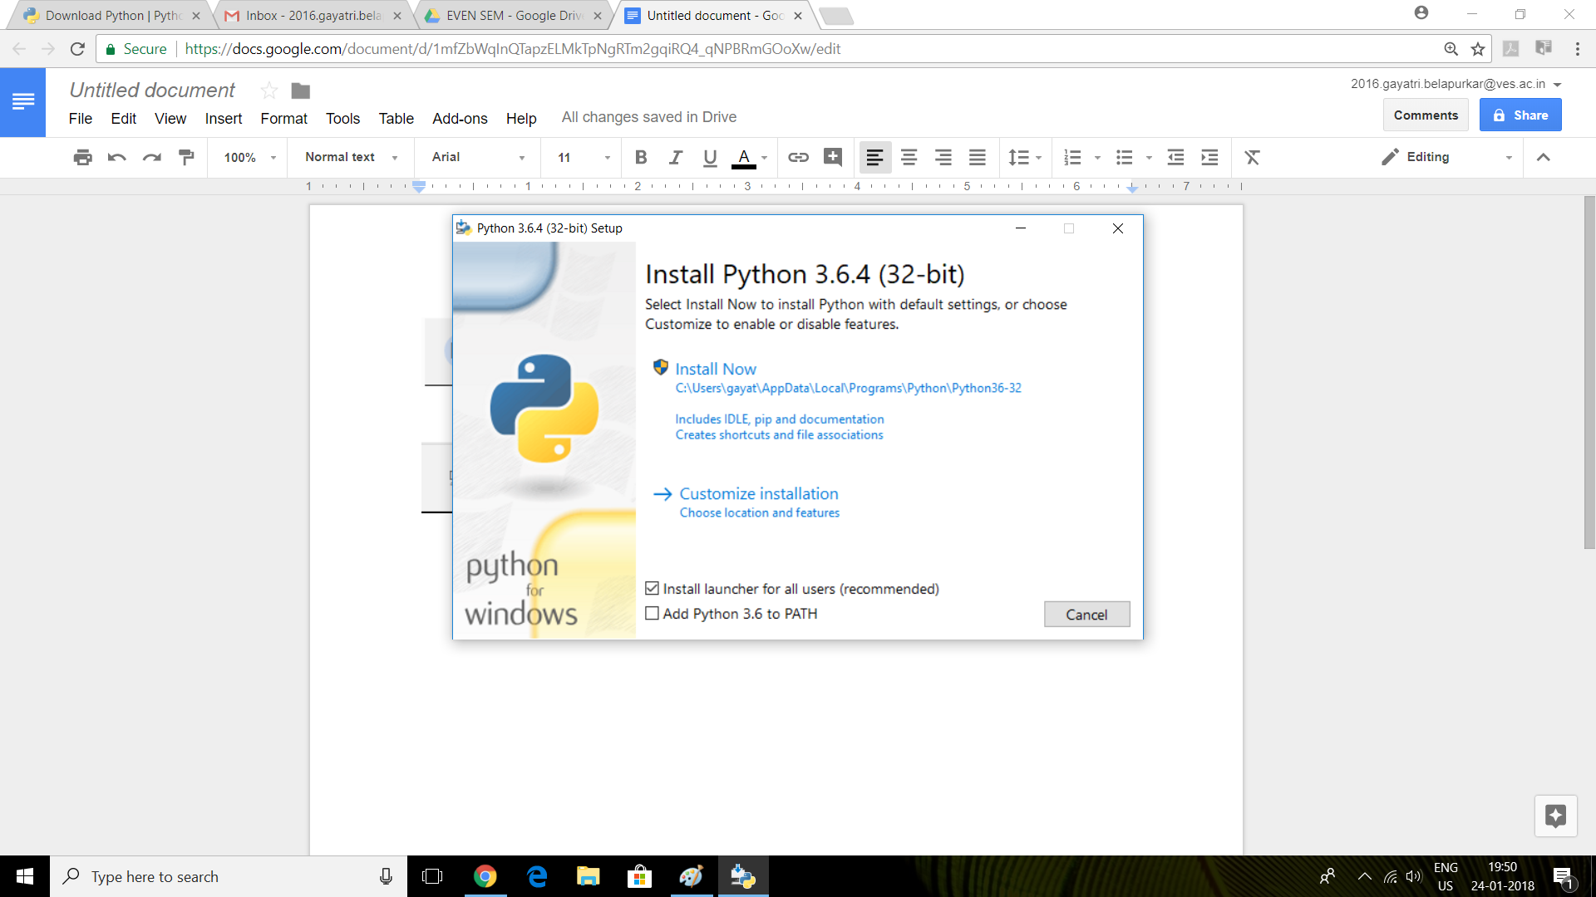

Ensure that the **Install launcher for all users (recommended)** and the **Add Python 3.6 to PATH** checkboxes at the bottom are checked. Then select **Install Now**

1. Click the **Yes** button.

A new **Python 3.6.2 (32-bit) Setup** pop-up window will appear with a **Setup Progress** message and a progress bar.

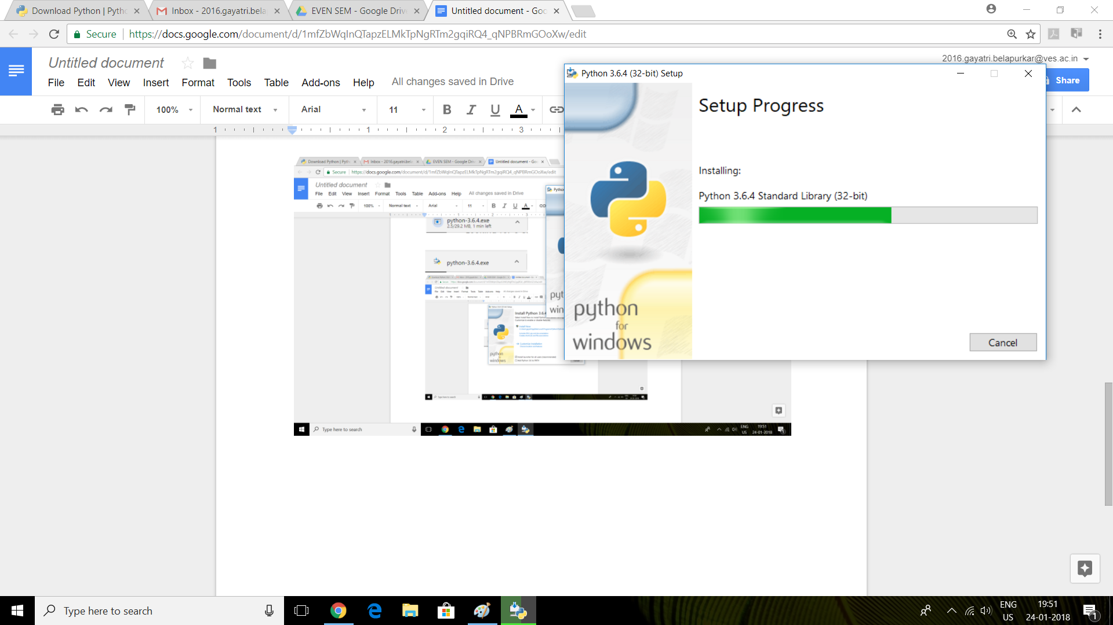

During installation, it will show the various components it is installing and move the progress bar towards completion. Soon, a new **Python 3.6.4 (32-bit) Setup** pop-up window will appear with a **Setup was successfully** message.

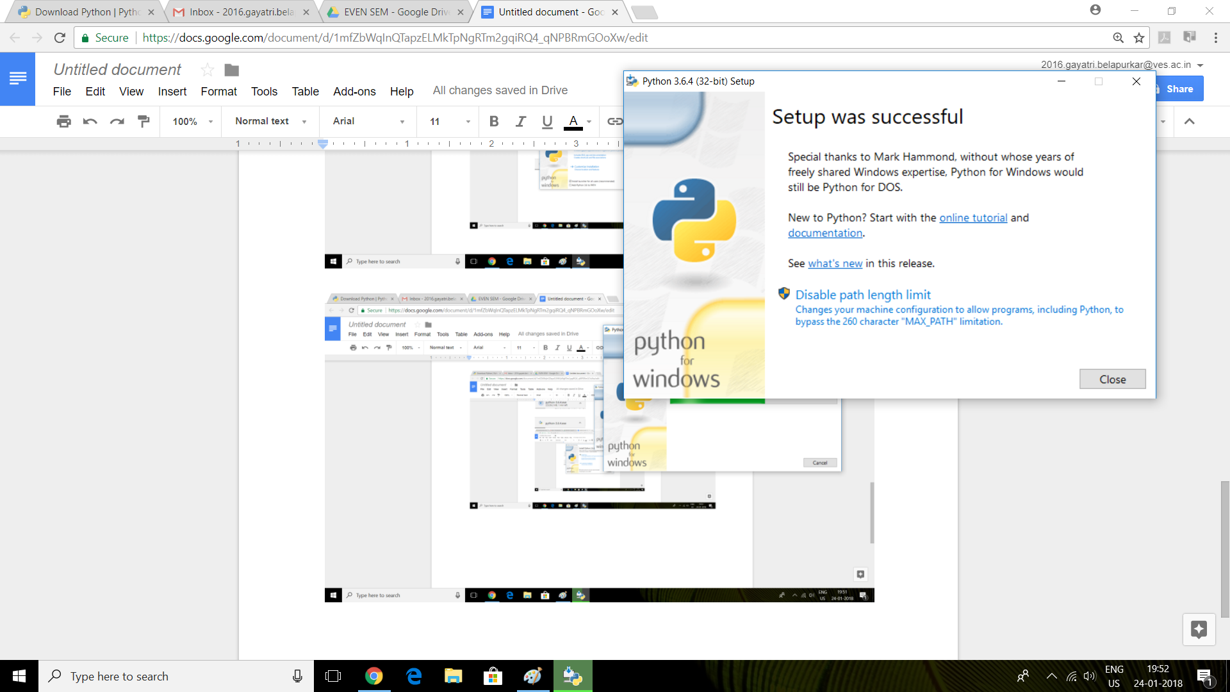

1. Click the **Close** button.

Python should now be installed.

Python programs can be executed by either using the python shell or by using command prompt of windows.

**Conclusion** :- Python is successfully installed and ready to use.